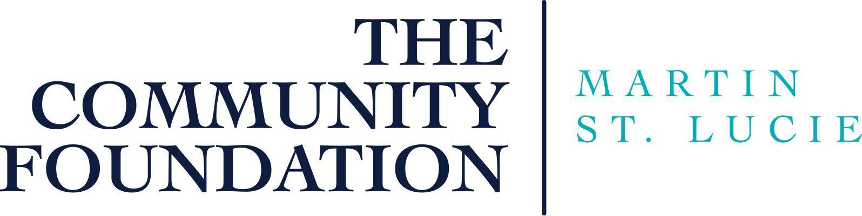

The Community Foundation Martin - St. Lucie is proud to partner with our back-office service provider,
Greater Horizons, to offer several easy contribution options.

Check
Make checks payable to The Community Foundation Martin - St. Lucie with a note in the memo section indicating the name of the fund-Premier Realty Charitable Fund II. Mail or deliver to:
The Community Foundation Martin - St. Lucie 851 SE Monterey Commons Boulevard Stuart, FL 34996

Credit card
Visit http://TheCommunityFoundationMartinStLucie.org. Mouse over (roll over) GIVE. Mouse over (roll over) CONTRIBUTIONS, select Contribute to an Existing Fund. Select the fund. Enter required information.

Please contact The Community Foundation for the link to make a payment to your fund via credit card.

Transfers
Please alert The Community Foundation Martin - St. Lucie of any transfer gift with a written communication or phone call. Instructions for each type of gift are detailed below. If you would like to make a gift of mutual funds, or restricted or closely held securities, please call us for instructions.

Wire transfer of cash
Please include the fund name on the wiring instructions.

Wire to: Bank of America One Kansas City Place 1200 Main
Kansas City, MO 64105 Fed Wire ABA #026009593 ACH ABA #081000032
For credit to: Greater Horizons - The Community Foundation Martin - St. Lucie
Account No.: 00-3490-478773
Contribution to: The Premier Realty Charitable Fund II

Transfer of government securities, stock, corporate bonds and other marketable securities Please include the fund name, a description of the shares and the name of the brokerage firm in the communication to The Community Foundation Martin - St. Lucie.

Government securities, including treasury bills, notes, bonds and FNMAs:
Please contact The Community Foundation at 772-288-3795 or via email at Elizabeth@tcfmsl.org and Admin@tcfmsl.org. The Community Foundation Martin - St. Lucie must authorize acceptance of these securities.

Stock, corporate bonds and other marketable securities:
DTC Firm: National Financial Services LLC
DTC #0226
For Credit to: Greater Horizons
Account #645-771593
Contribution to: The Premier Realty Charitable Fund II

